**Sales Analytics Business Case**

Leonel Ale

Contents

Business Request & User Stories 3

Data structure 4

Dimension tables 5

Customers 5

Calendar 5

Products 6

Fact tables 7

Sales 7

Dashboards 8

Sales overview 8

Customer details 9

# Business Request & User Stories

The business request for this data analyst project was an executive sales report for sales managers. Based on the request that was made from the business we following user stories were defined to fulfill delivery and ensure that acceptance criteria’s were maintained throughout the project.

|  |  |  |  |  |
| --- | --- | --- | --- | --- |
| **#** | **As a (role)** | **I want (request / demand)** | **So that I (user value)** | **Acceptance Criteria** |
| **1** | Sales Manager | To get a dashboard overview of internet sales | Can follow better which customers and products sells the best | A Power BI dashboard which updates data once a day |
| **2** | Sales Representative | A detailed overview of Internet Sales per Customers | Can follow up my customers that buys the most and who we can sell more to | A Power BI dashboard which allows me to filter data for each customer |
| **3** | Sales Representative | A detailed overview of Internet Sales per Products | Can follow up my Products that sells the most | A Power BI dashboard which allows me to filter data for each Product |
| **4** | Sales Manager | A dashboard overview of internet sales | Follow sales over time against budget | A Power Bi dashboard with graphs and KPIs comparing against budget. |

# Data structure

To create the necessary data model for doing analysis and fulfilling the business needs defined in the user stories the following tables were extracted using SQL.

One data source (sales budgets) were provided in Excel format and were connected in the data model in a later step of the process.

Below are the SQL statements for cleansing and transforming necessary data.

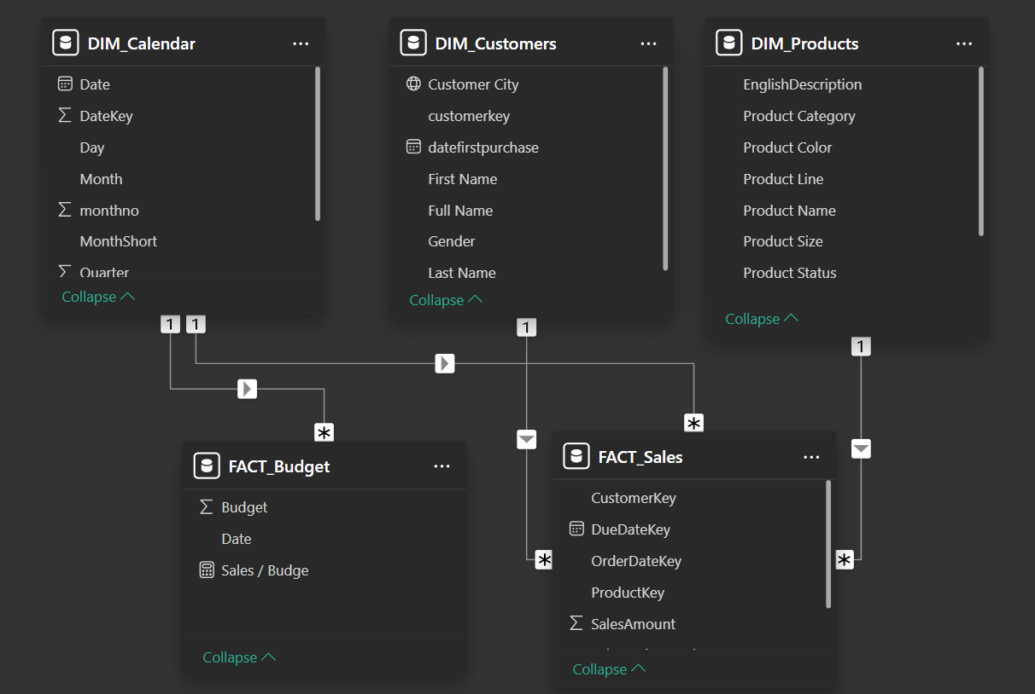

## Dimension tables

### Customers

This query retrieves cleansed customer data, including names, gender, first purchase date, and city. It transforms gender codes into readable formats, combines first and last names for a full name field, and joins geography details for enhanced context. Results are sorted by customer key.

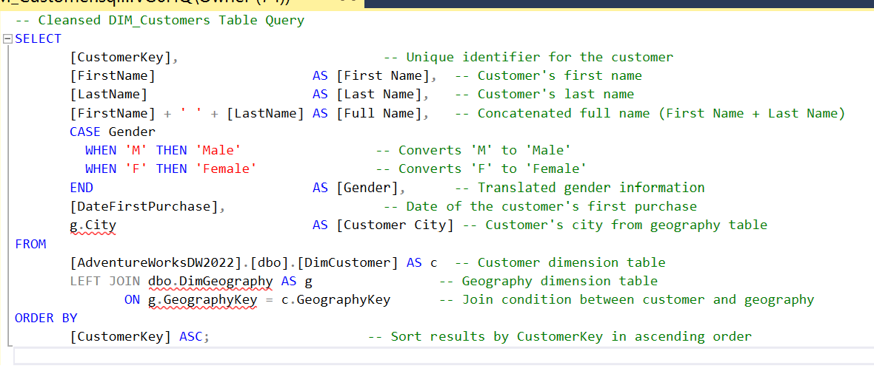

### Calendar

This query retrieves a structured view of the date dimension table, including full and abbreviated date details such as day, month, year, week number, and quarter. It filters dates from 2012 onwards to ensure relevance and provides both textual and numeric representations for easy analysis.

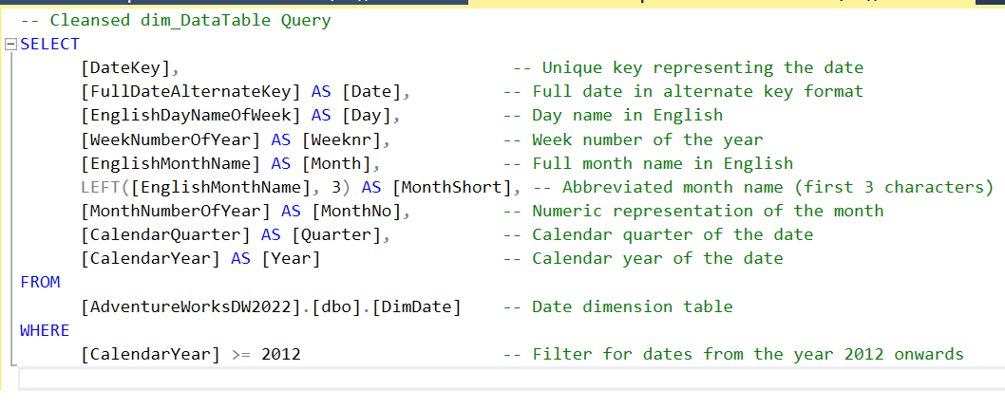

### Products

This query retrieves a detailed and cleansed product dataset, including product name, category, subcategory, color, size, and description. It ensures data quality by setting a default status for missing values and organizes the output in ascending order by product key.

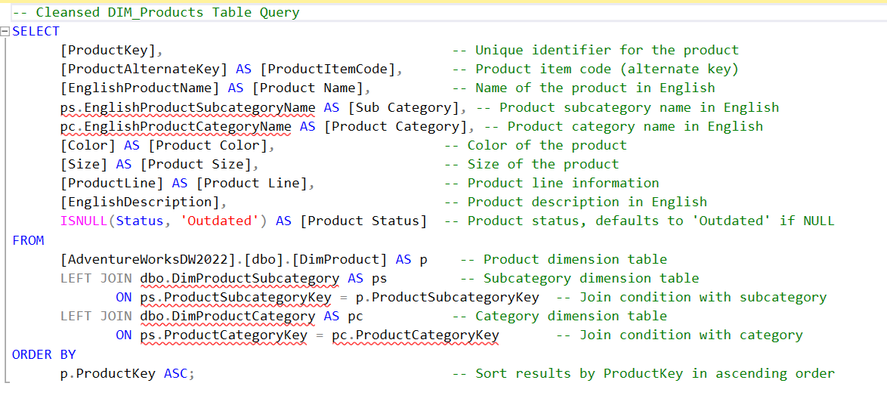

## Fact tables

### Sales

This query retrieves key details from the Internet Sales fact table, including product, customer, and order-specific data. It includes an optional filter to limit sales to the last 12 years and organizes the results chronologically by order date.

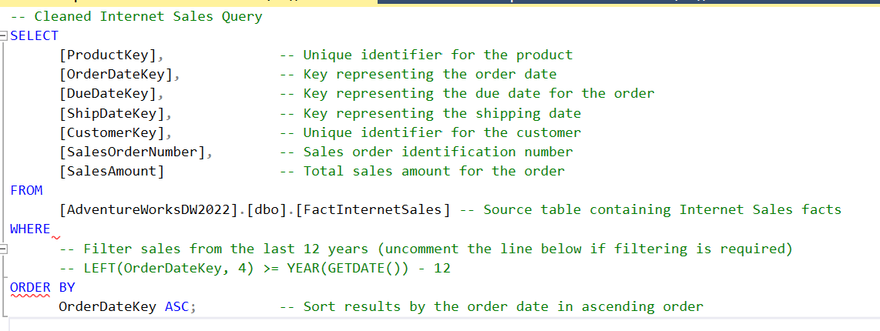

# Dashboards

Users can filter by year, month, product, subproduct, and customer, with synchronized filters across visuals.

## Sales overview

This Power BI dashboard integrates all cleansed tables to provide a comprehensive sales overview. The dashboard features a donut chart for product distribution, top 10 products and customers, a sales trend over the year, and a global heat map highlighting city-level sales performance.

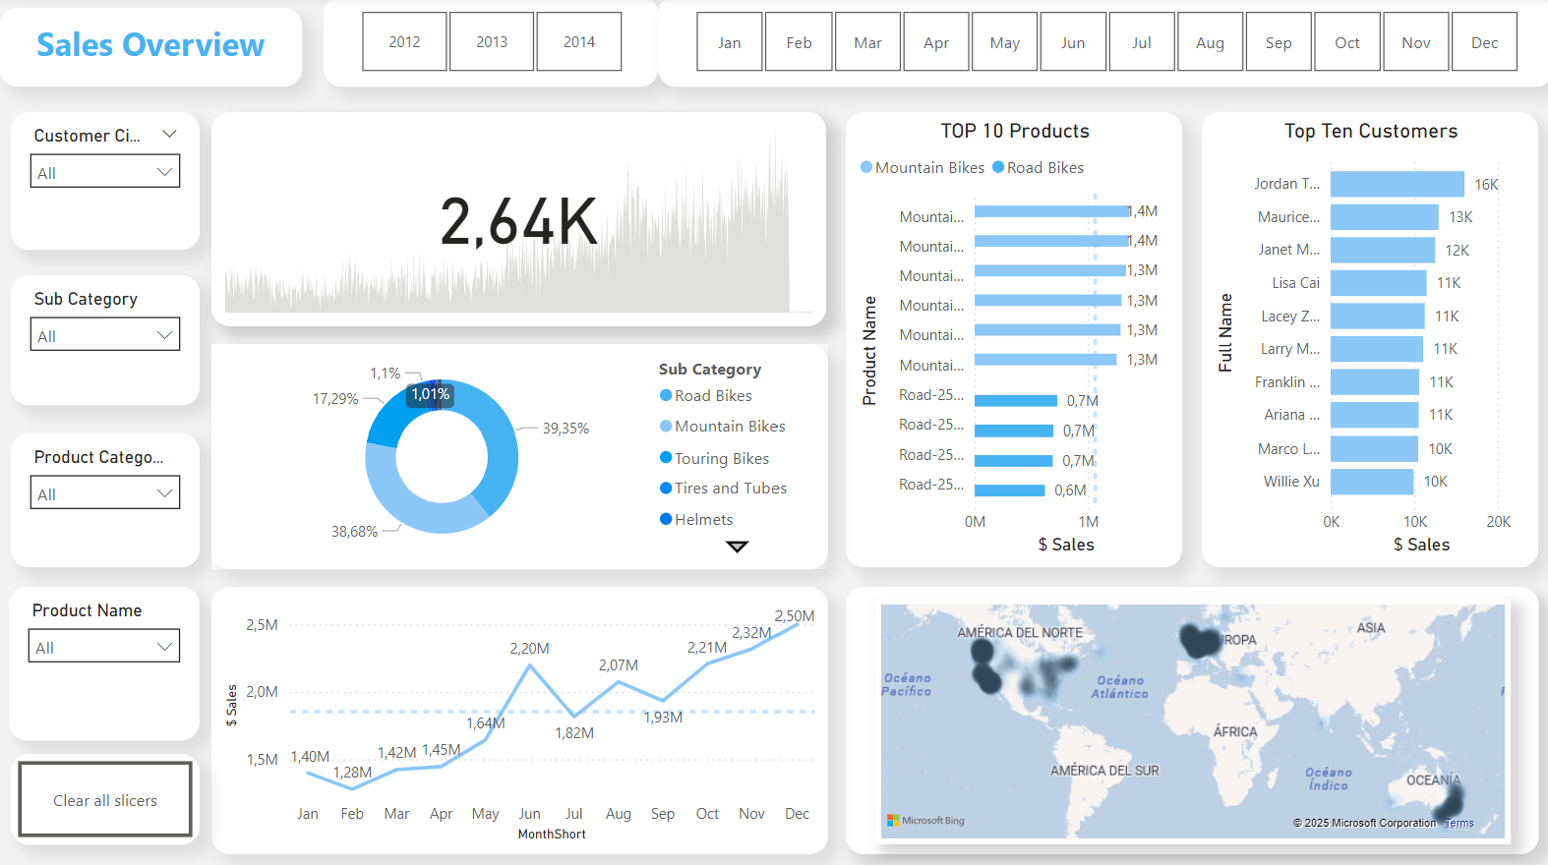

## Customer details

The Customer Details dashboard enhances analysis with a detailed table featuring a heat map of customer activity by month. This visualization highlights patterns and trends in customer behavior, complementing the insights from the sales overview. Filters remain synchronized for seamless exploration.

